**Docker Advanced Assignment**

**Take an existing Dockerfile and optimize it for build speed and image size.**

Code Reference = https://github.com/karthikmnmysore/nagarro-bench-docker-advance/tree/main/optimize-code

Building Docker.old file

Building Dockerfile which is optimized

Compare the image size of both Docker files



Build the Optimized Docker file



Access from Browser

Stop and delete running container

**Use multi-stage builds where appropriate.**

Code reference = https://github.com/karthikmnmysore/nagarro-bench-docker-advance/blob/main/optimize-code/README-multi.md

Build Multi stage Dokcer file

Image size optimize



Run container



Stop container

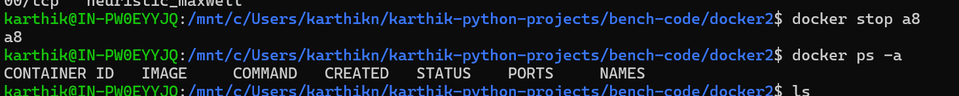

Set up a custom Docker network and connect multiple containers to it.

Code reference = <https://github.com/karthikmnmysore/nagarro-bench-docker-advance/blob/main/network/README-docker-network.md>

Creating Network, Run Nginx, Run my-busybox

Run the BusyBox container in same network and do ping test

Cleanup resources

**Use Docker commands to inspect and manage the network.**

Code reference - <https://github.com/karthikmnmysore/nagarro-bench-docker-advance/blob/main/network/README-docker-inspect.md>

Create network, Run Nginx and Busy-box container, and Inpect network

Manage and Clean-up network

**Create and manage Docker volumes to persist data for your containers.**

Code reference - <https://github.com/karthikmnmysore/nagarro-bench-docker-advance/blob/main/volume/README-volume.md>

Create Docker volume, Inspect Volume, Run with Mysql container

Create Network if not created, then Enter into the mysql container

Testing Docker Volume

Create Database testdb inside MySql, then stop and remove mysql container. Then again create mysql container with same Volume name. We can see the testdb by using Show database command.

Manage Volume

Inspect volume, prune Volume and clean up volume and mysql container

**Use named volumes and bind mounts and demonstrate how they can be used in a multi-container setup.**

Code reference = <https://github.com/karthikmnmysore/nagarro-bench-docker-advance/blob/main/volume/README-volume-bind-docker-compose.md>

Testing Data persistence, create database

Also see the MySql bind

Stop the container and restart container

Now restart containers,

Test now if our testdb database present or not.

Edit the html/index.html, then refresh page

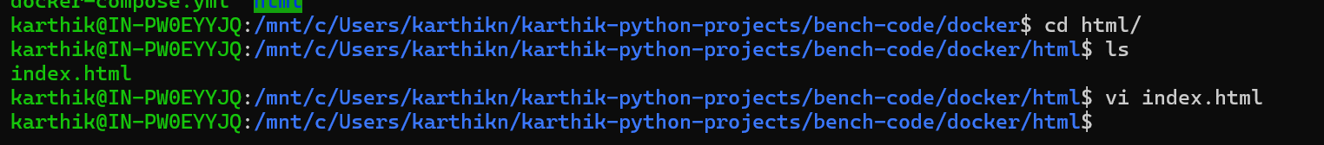

Now Clean-up all docker container, network, volume

**Backup and restore data from Docker volumes.**

Code reference = <https://github.com/karthikmnmysore/nagarro-bench-docker-advance/blob/main/volume/README-Backup-Restore-Docker-Volume.md>

Run the mysql container



Connect to MySql container and create database

Take the backup of volume

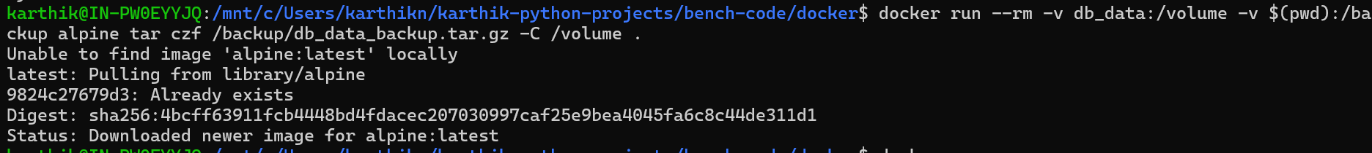



Remove Volume

Recreate volume and restore old volume, then test if our testdb database exists or not

Clean up resource

**Implement security best practices in your Docker setup, including user permissions, image vulnerability scanning, and secret management. +**

**Configure Docker to run containers with the least privilege.**

Code reference = <https://github.com/karthikmnmysore/nagarro-bench-docker-advance/blob/main/security/README-docker-security.md>

To generate app.Jar file from windows

echo "public class Dummy { public static void main(String[] args) { System.out.println(\"Hello Spring Boot\"); }}" > Dummy.java

javac Dummy.java

echo "Main-Class: Dummy" > manifest.txt

jar cfm app.jar manifest.txt Dummy.class



Dockerfile build and docker-compose.yml fill up

Connecting ro MySql container with Secrets , not defined in docker-compose environment variable

Showing permission denied for Root file

Clearing Docker resources

BONUS =

**Implement a log aggregation system for your Dockerized application to collect, parse, and visualize logs, providing insights into the performance and behaviour of your application.**

Code reference = <https://github.com/karthikmnmysore/nagarro-bench-docker-advance/tree/main/Monitoring-tool>

